**UNIT 4**

**11.1.2 Performance Measures and Benchmarks**

**SPEC Benchmark Suite**: SPEC (System Performance Evaluation Cooperation group) maintains benchmark suites like SPEC2006 for desktop computers.

It follows a standardized methodology to

1. measure execution time,
2. normalize to a reference computer, and
3. report performance as SPECmark.

**Other Benchmark Suites:** Apart from SPEC, there are benchmark suites like

1. SPECviewperf for graphics,
2. SPECSFC for file servers, and
3. SPEC MPI2007 and SPEC OMP2012 for parallel computing.

**Compiler Influence**: Benchmark results can vary based on the compilers used and their optimization levels.

It's important to record the compiler and optimization level used during benchmarking to ensure consistent and meaningful performance comparisons.

**11.2 SOURCES OF PARALLEL OVERHEAD**

Parallel computers in practice do not achieve linear speedup or an efficiency of one, as mentioned earlier, because of parallel overhead. The major sources of overhead in a parallel computer are

1. inter-processor communication,
2. load imbalance,
3. inter-task synchronization, and
4. extra computation.

All these are problem or application dependent.

**11.2.1 Inter-processor Communication**

Inter-processor communication is a crucial aspect of parallel computing, but it also introduces significant overhead.

**Time for Data Transfer**: The time required to transfer data between processors is a major component of parallel computing overhead. If each of the p processors spends *t*comm​ units of time for data transfer, then the total time contributed by inter-processor communication is

*t*comm​×*p* units.

**Overlap Factor**: In some cases, there can be overlap between computation and communication. The overlap factor *α*0 where (0<*α*0​<1) represents the computation and communication overlap factor

**Impact of Communication Traffic**: Excessive inter-processor communication can saturate the available network bandwidth. (utilizing network to its utmost capacity)

To minimize the impact of inter-processor communication overhead, parallel computing systems and algorithms often employ optimization techniques such as:

**Communication Avoidance**: Reducing unnecessary communication by optimizing data access patterns and minimizing data movement between processors.

**Data Locality**: Ensuring that data accessed by processors is stored close to them in memory or cache, reducing the need for frequent data transfers.

**Network Optimization**: Using high-speed interconnects, network protocols, and routing algorithms to optimize communication performance and avoid network congestion.

**11.2.3 Inter-task Synchronization**

During the execution of a parallel program some or all processors must synchronize at certain points due to dependencies.

For example, if subtask B running on processor PB depends on subtask A running on processor PA, then the execution of subtask B is delayed till subtask A completes its execution.

if processors are not ready for synchronization at the same time, it can lead to increase parallel overhead.

This overhead can be a significant concern in parallel computing, especially if synchronization points are frequent or if processors are frequently waiting on each other.

Efficient synchronization mechanisms, such as

* fine-grained locking,
* non-blocking algorithms, or

can help reduce this overhead.

**11.2.4 Extra Computation**

Sometimes, the most efficient sequential algorithm for a problem does not naturally lend itself to parallelization with a high degree of concurrency. ( mean that the nature of the problem or the algorithm makes it challenging to split the work into many smaller tasks that can be executed simultaneously. )

The extra computations required in the parallel algorithm, beyond what the sequential algorithm would perform, are indeed considered part of the parallel overhead.

Efforts are typically made in parallel computing to minimize this overhead as much as possible. This can involve

* optimizing parallel algorithms,
* using efficient synchronization techniques, and
* leveraging hardware capabilities like
  + multi-core processors or
  + specialized accelerators to mitigate the impact of extra computations on overall performance.

**11.2.5 Other Overheads**

Parallel overhead also includes factors such as

* task creation,
* task scheduling,
* task termination,
* processor (shared) memory
* interconnect latency,
* cache coherence enforcement, etc.

It may be noted that a coarse-grained task usually has less parallel overhead but potentially less degree of parallelism, while a fine-grained task has a larger overhead cost with a potentially larger degree of parallelism.

11.2.6 Parallel Balance Point

As you increase the number of processors used to solve a problem, there's initially a decrease in execution time due to the workload being divided among more processors.

However, at a certain point, adding more processors may not lead to further decreases in execution time. This is because the additional parallel overhead introduced by managing more processors can outweigh the benefits of parallelism.

*The parallel balance point* represents the optimal number of processors for a given problem size. Using fewer processors may lead to underutilization and longer execution times, while using more processors can lead to increased overhead and diminishing returns in terms of performance improvement.

This concept is important in designing parallel algorithms and systems. It helps determine the appropriate level of parallelism to achieve the best performance without wasting resources or introducing unnecessary overhead.

*Space sharing*, where each program is allocated a subset of available processors based on its characteristics and parallelism profile, is one way to optimize resource utilization in parallel computing environments.

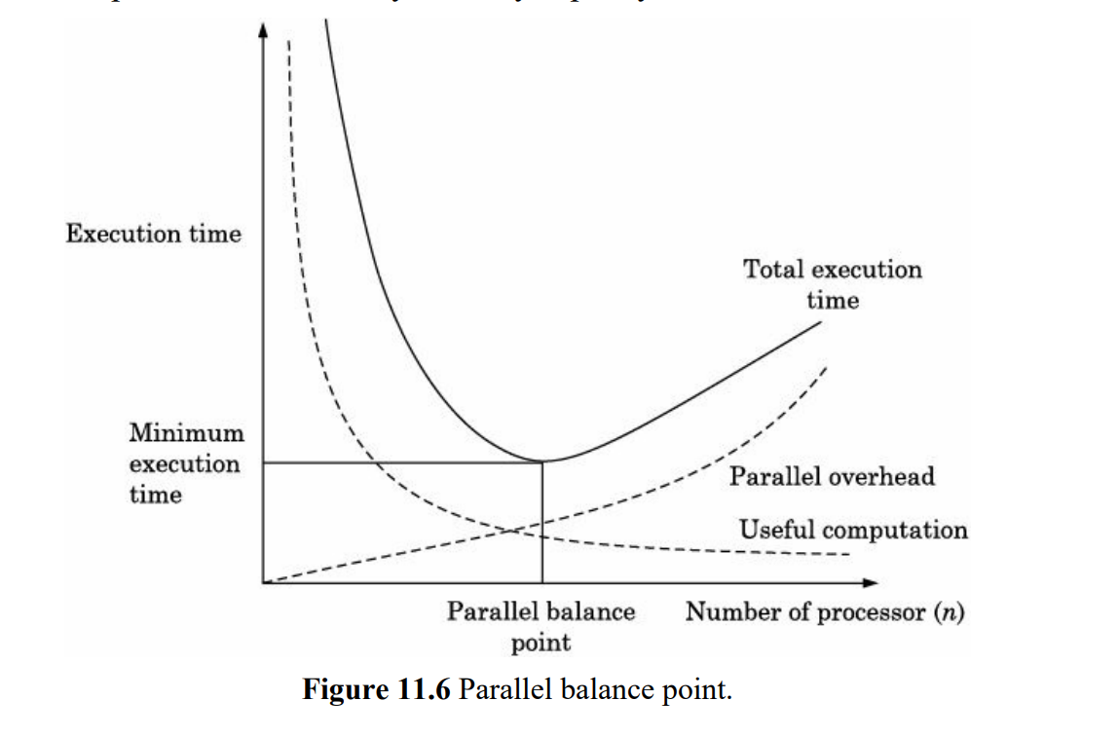

**11.3 SPEEDUP PERFORMANCE LAWS**

We now describe three speedup performance laws.

1. Amdahl’s law - is based on a fixed problem size or a fixed work load.
2. Gustafson’s law - is for scaled problems, where the problem size increases with the increase in machine size (i.e., number of processors).
3. Sun and Ni’s law - is applied to scaled problems bounded by memory capacity.

**11.3.1 Amdahl’s Law**





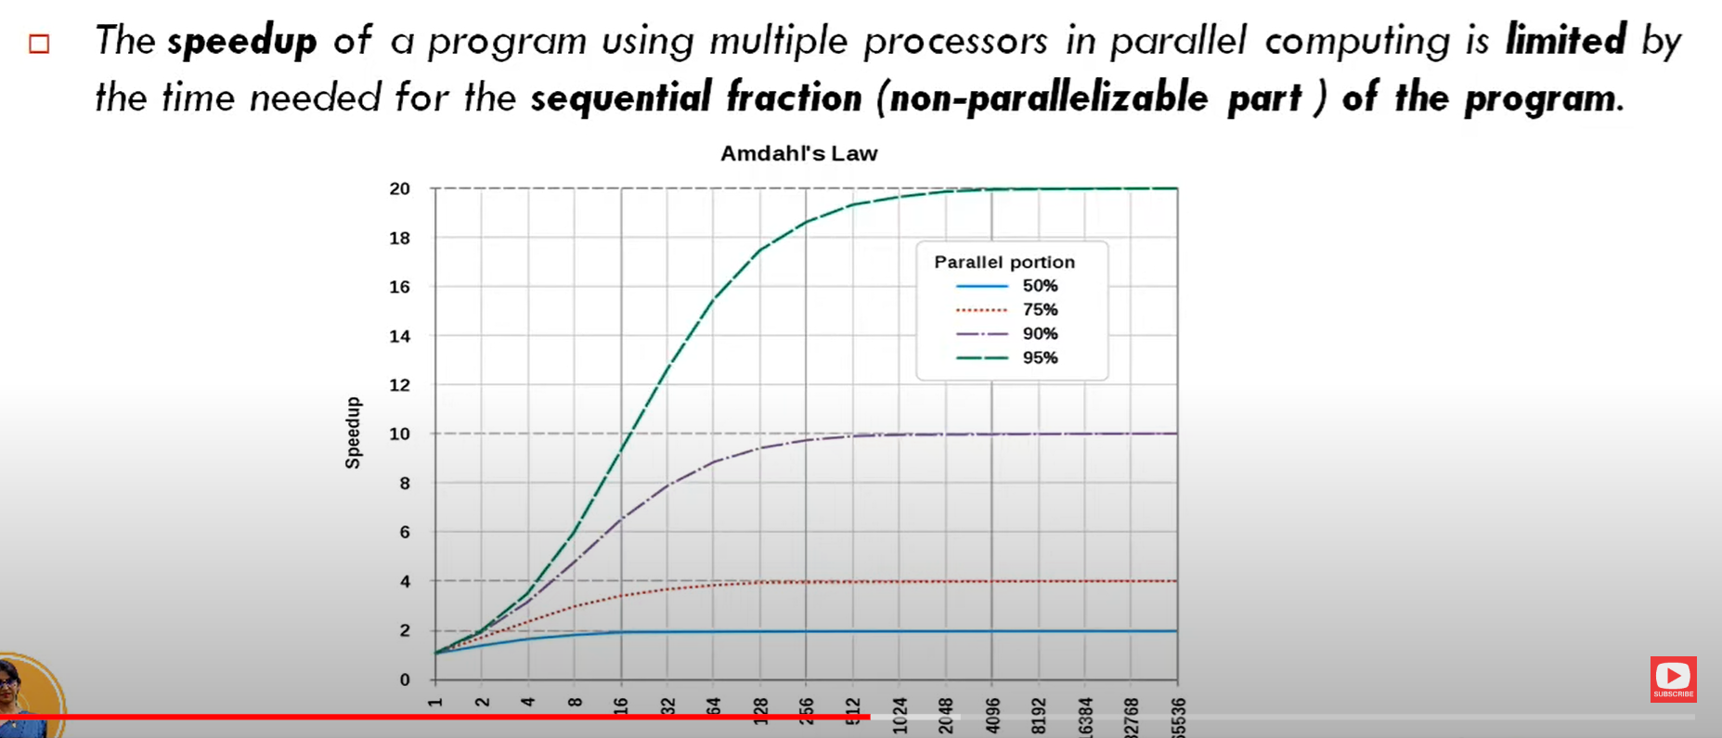



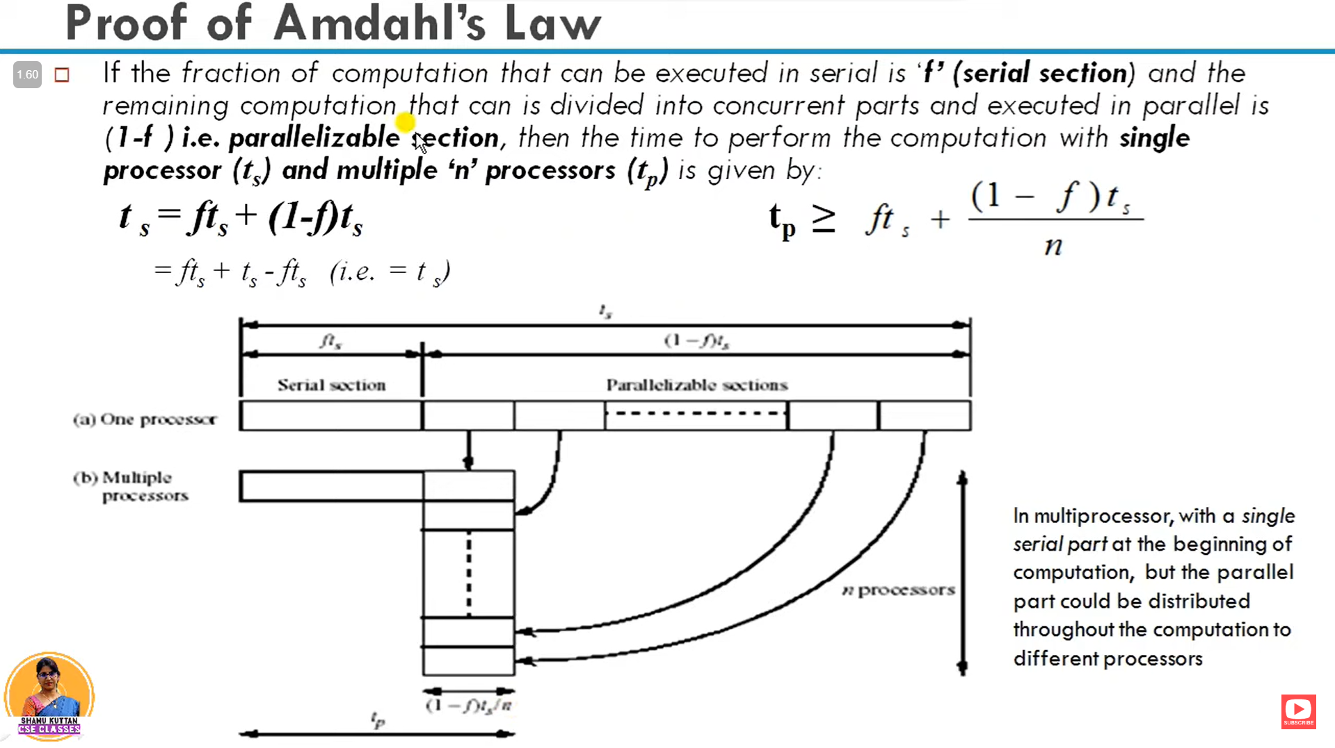





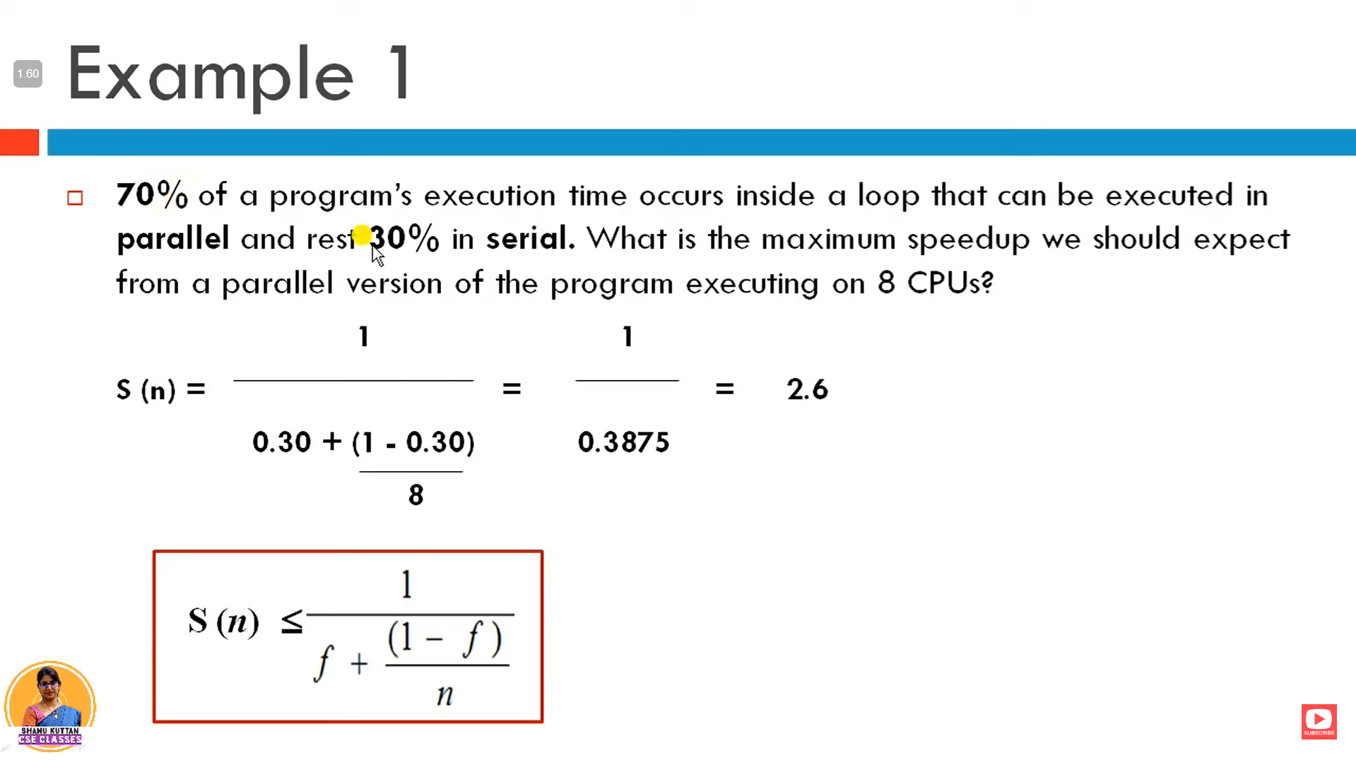

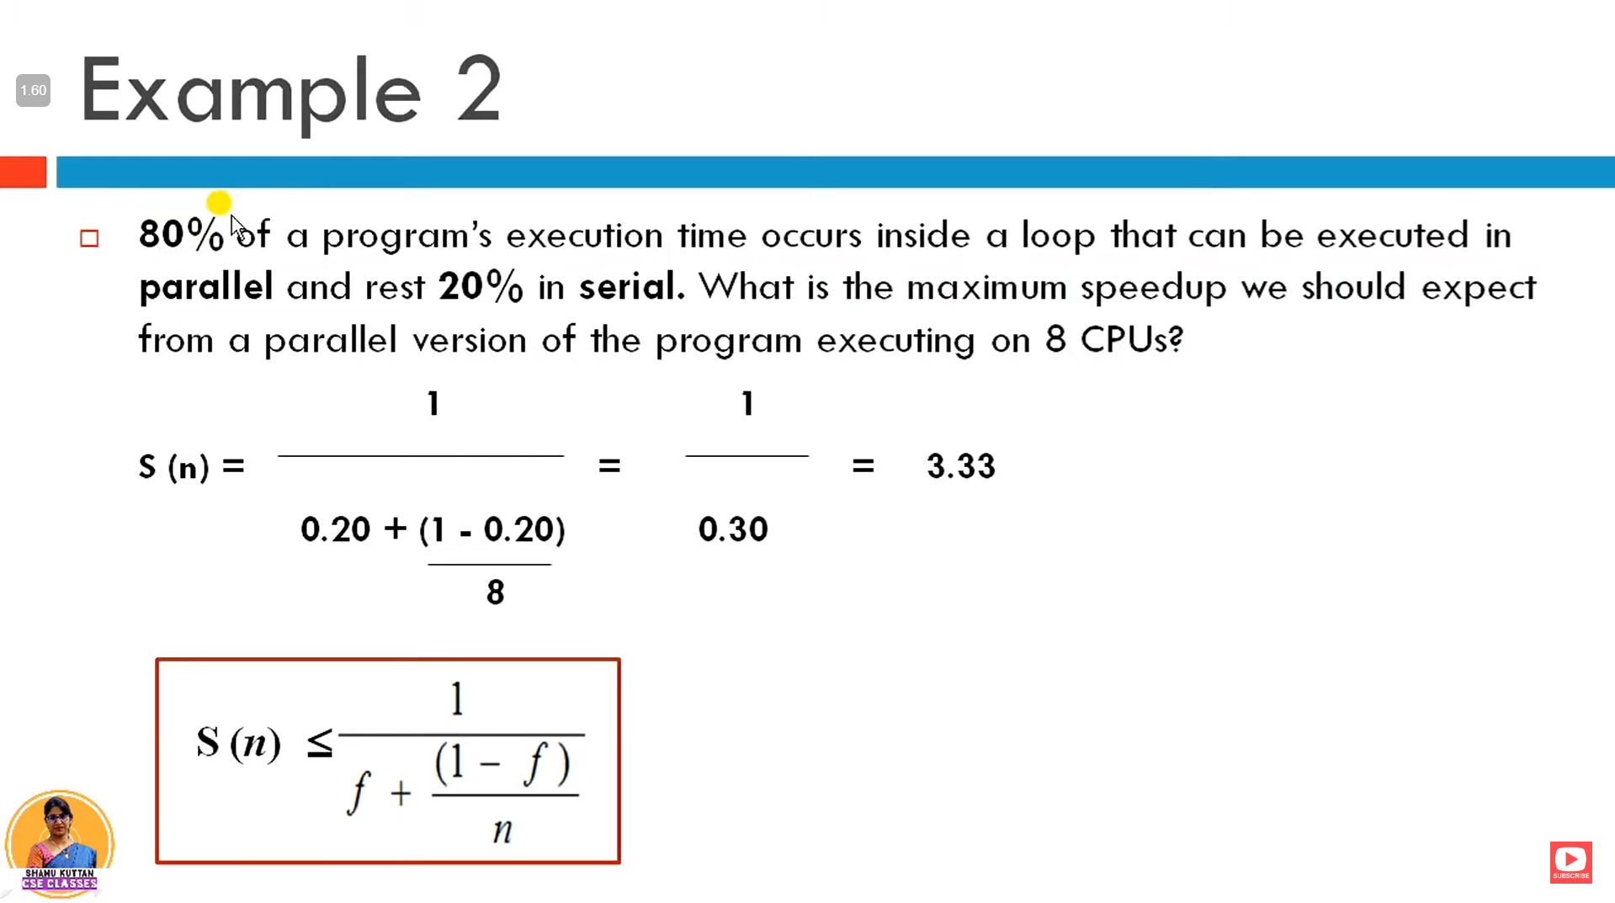

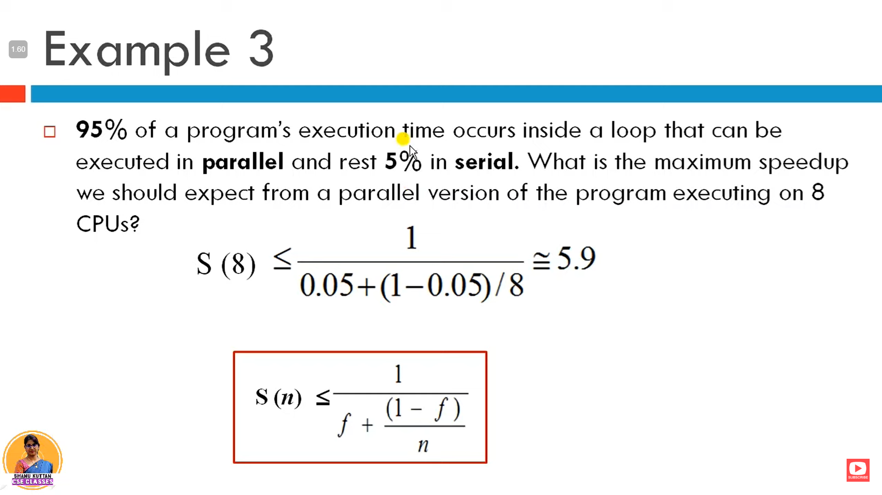

Sequential Bottleneck:

* The sequential bottleneck refers to the limitation imposed by the sequential portion of the program on achieving speedup.
* Increasing the number of processors **beyond a certain point doesn't eliminate this bottleneck.**

**Gustafson's Law**

Gustafson's Law, introduced by John Gustafson in 1988, offers a different perspective on parallel computing compared to Amdahl's Law. Here are the key points and implications of Gustafson's Law:

1. Problem Size Scalability:

- Gustafson's Law is motivated by accuracy-critical applications where achieving a more accurate solution is more important than reducing response time.

- It relaxes the assumption of a fixed problem size and focuses on scaling the problem size with the machine size to maintain a constant execution time.

2. Scaled Workload:

- As the machine size increases, the work load can be increased to create a larger problem size.

- Coarser grids or smaller problem instances require fewer computations, while finer grids or larger problem instances demand more computations for greater accuracy.

3. Fixed Execution Time:

- The goal under Gustafson's Law is to solve the largest problem size possible on a larger machine within a fixed execution time, rather than solving smaller problems on smaller machines.

4. Speedup Formula:

- Let *Ts* be the constant time taken for sequential operations and *Tp*​(*n*,*W*) be the time taken for parallel operations with a workload W using n processors.

- The speedup S'(n) achieved with n processors under Gustafson's Law is given by:

S'(n) = n(1 - *α*)

Where *α* is the fraction of the workload that consists of sequential operations.

5. Weak Scaling:

- Gustafson's Law also considers weak scaling, where efficiency is maintained by increasing the problem size proportionally to the number of processors.

6. No Sequential Bottleneck:

- Gustafson's Law suggests that by scaling the problem size sufficiently with the number of processors, the sequential bottleneck can be avoided.

- This is achieved by keeping all processors busy through increased problem size, resulting in a flatter speedup curve compared to Amdahl's Law.

Overall, Gustafson's Law emphasizes the importance of scalability in parallel computing for accuracy-critical applications. By scaling both problem size and computing resources, it aims to achieve more accurate solutions within a fixed execution time, mitigating the limitations posed by sequential bottlenecks observed in Amdahl's Law.

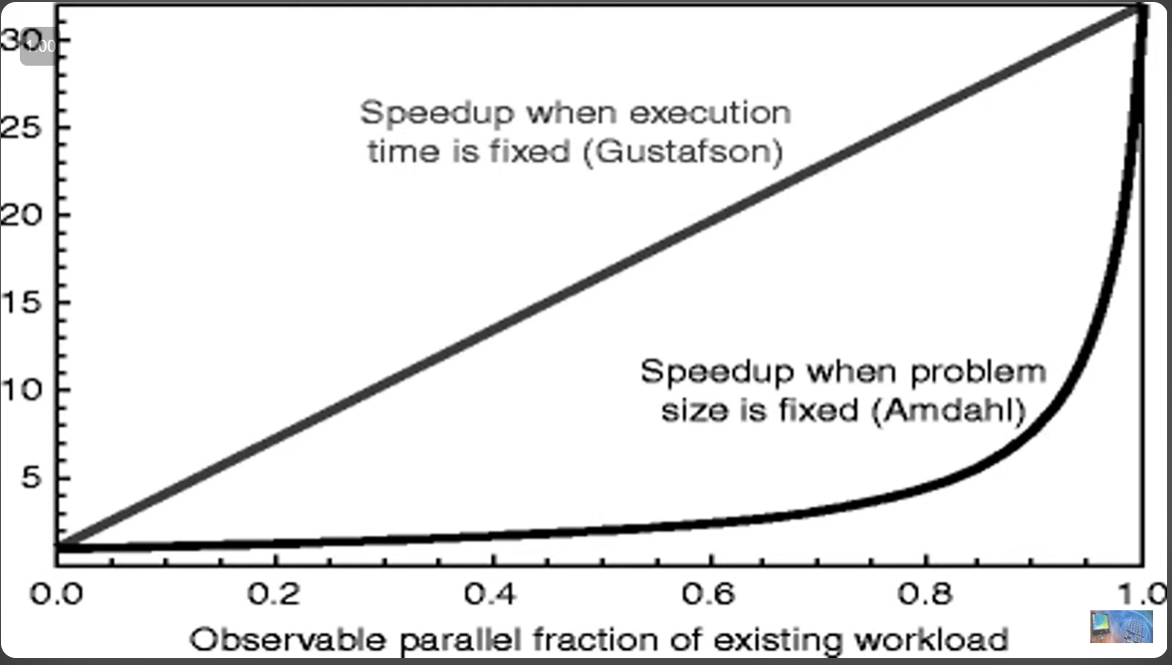

**Sun and Ni's Law**

Sun and Ni's Law, developed in 1993, introduces a memory-bounded speedup model that combines elements of both Amdahl's Law and Gustafson's Law. Here are the key points and implications of Sun and Ni's Law:

1. Maximizing Processor and Memory Capacities:

- Sun and Ni's Law aims to maximize both processor and memory capacities in a parallel computing environment.

- The idea is to solve the largest possible problem limited by the available memory capacity, leading to higher speedup, efficiency, and resource utilization.

2. Distributed Memory Multiprocessor System:

- In a distributed memory multiprocessor system, each processor has limited local memory capacity.

- By collectively using a large number of processors, the total memory capacity increases proportionally, enabling the system to handle larger problems through program or data partitioning.

3. Scaled Workload:

- Sun and Ni's Law assumes a scaled workload, where the problem size is increased to match the available memory capacity and maintain a fixed execution time.

- This approach allows for solving larger and more complex problems, leading to higher accuracy and better solutions.

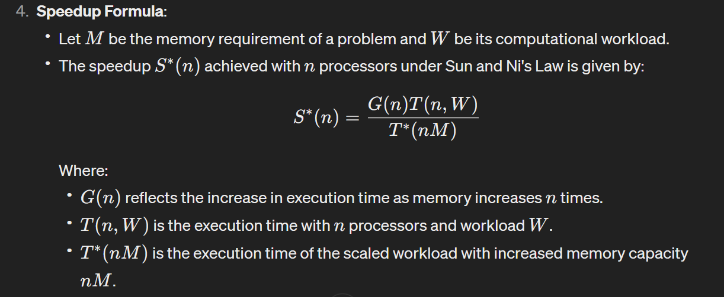

5. Special Cases:

- Sun and Ni's Law encompasses special cases such as Amdahl's Law and Gustafson's Law.

- Amdahl's Law (Case 1) corresponds to fixed problem size.

- Gustafson's Law (Case 2) corresponds to increasing workload with increased memory.

- When the workload grows faster than memory requirement (Case 3), the memory-bound model may yield higher speedup and better resource utilization compared to the fixed execution time model.

Overall, Sun and Ni's Law provides a framework for optimizing parallel computing by leveraging both processor and memory capacities effectively. It emphasizes scaling the workload and problem size to achieve higher accuracy, speedup, and resource utilization, especially in memory-bound applications.

**UNIT 3**

**4.3 VECTOR COMPUTERS**

Vector computers leverage temporal parallelism, particularly through pipeline processing, to achieve high performance. The most important unit of a vector computer is the pipelined arithmetic unit.

Consider addition of two floating point numbers x and y.

A floating point number consists of two parts, a mantissa and an exponent.

number : 12345.55666 -> mantissa and exponent?

In the number 12345.55666, the mantissa is 1.234555666 and the exponent is 4.

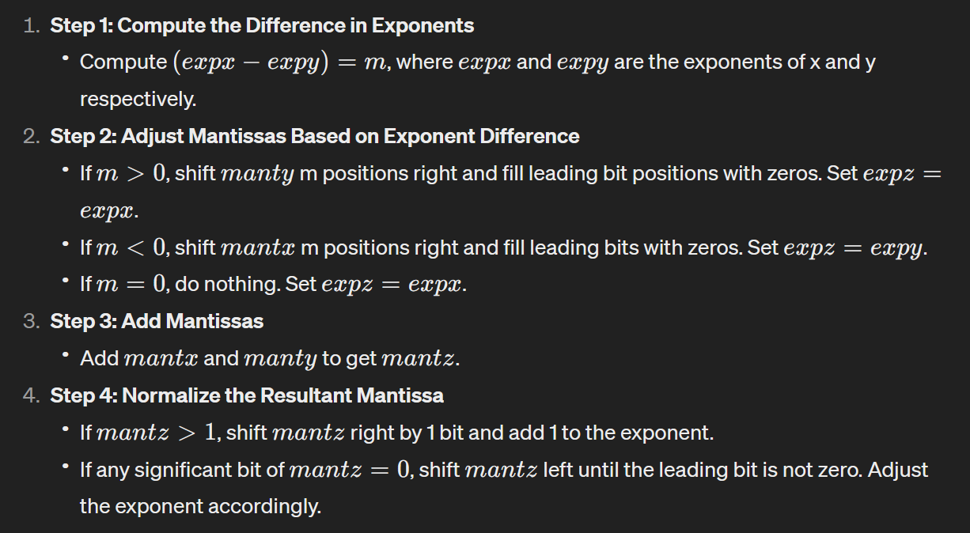

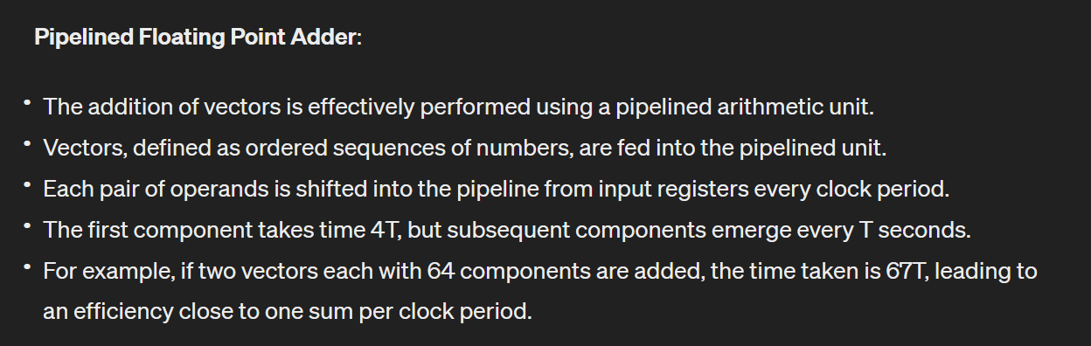

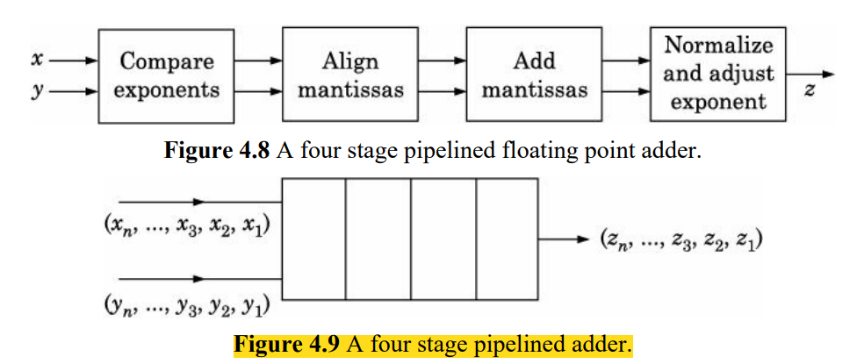

We discussed vector add. Vector subtract is not different (it is the complement of addition).

Pipelined multiply and divide units are more complicated to build but use the same general principle.

Pipelined arithmetic operations don't face issues of data dependency because each component of the vector operates independently. This means that multiple operations can be executed simultaneously without waiting for others to complete.

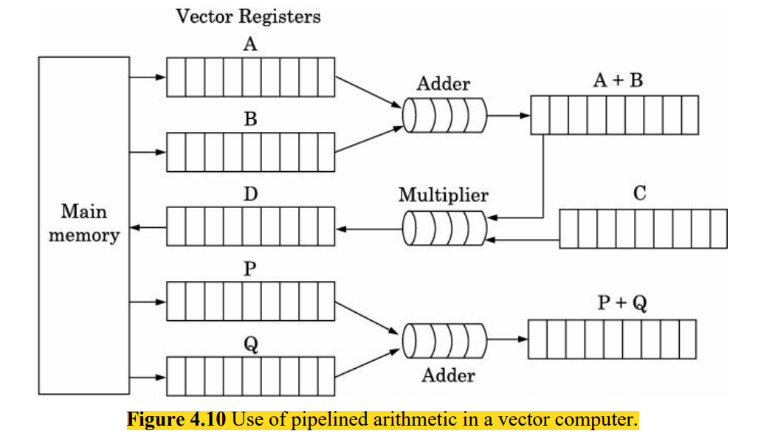

Observe that an important part is a set of vector registers which feed the vector pipelined adders and multipliers.

Typically vector registers used to store 64 floating point numbers, which are each 64 bits long.

Recent vector machines built by NEC of Japan [Nakazato, et al., 2008] use vector registers which store 256 double precision (64 bits) numbers

VECTOR CHAINING : Observe in Fig. that the output of the pipeline adder unit may be fed to another pipelined multiply unit. As the components of (A + B), (a1 + b1 ), (a2 + b2 ) … (an + bn ) are generated, they are multiplied by the components of C, namely, c1 c2 … cn to produce (a1 + b1 ) × c1 , (a2 + b2 ) × c2 , (a3 + b3 ) × c3 , ... (an + bn ) × cn respectively and stored in the vector register D. This method of feeding the output of one pipelined arithmetic unit to another is called vector chaining.

main memory of a vector computer is structured and organized to deal with the speed mismatch between memory retrieval and processing speed.

The speed of retrieving data from the main memory in a vector computer is typically around 10 times slower than the speed of processing.

To address this speed mismatch, the main memory is organized into multiple "banks." Each bank stores a portion of the data, and successive components of a vector are stored in successive memory banks.

When data is needed, commands for retrieval are issued to these memory banks successively. The outputs retrieved from the banks are stored in a buffer before being shifted into the vector register.

The retrieval and shifting of values into the vector register are overlapped, ensuring that one word of data is shifted into the vector register per clock cycle. This overlapping optimizes the memory access and utilization.

The number of memory banks should be equal to or larger than the clock cycles needed to read a word from memory. This ensures efficient data retrieval without bottlenecks.

Advanced vector supercomputers like Cray YMP can read and process multiple vectors simultaneously from memory. This requires multiple memory banks corresponding to the clock cycles needed for memory access. For example, if memory access takes 6 clock cycles, having 16 banks would be sufficient to store and retrieve vectors A and B appropriately.

Another important problem in designing vector computing units is handling of vector stride.

The stride is the subscript difference between successive elements of a vector.

For example, in the loop

for i := 1 to 100 with step size of 5

do a(i) = b(i) + c(i)

end for

the stride is 5 as successive elements of the vectors b and c which are added are: b(1), b(6), b(11), ..., c(1), c(6), c(11) .... In this case the vector unit must retrieve b(1), b(5), b(11), …, etc., and store them in successive slots of a vector register.

If the stride equals the number of banks in the main memory retrieval of vector elements will be slowed down as successive requests for retrieval will go to the same memory bank.

Vector computers typically include instructions that allow specifying a stride value along with a starting address. This feature enables efficient loading of vector components into vector registers, ensuring that elements separated by the specified stride are stored in successive slots of the register.

**INTERCONNECTION NETWORKS**

In computer architecture, interconnection networks play a crucial role in connecting various components. They are designed to provide efficient communication pathways between these components, thereby enhancing overall system performance.

Interconnection networks can be classified into two main categories: direct networks and indirect networks.

**Direct Networks**

In direct networks, each computing node (processor or memory module) is directly connected to its neighboring nodes through dedicated communication lines. This direct connection ensures low latency and high bandwidth low latency ensures quick response times, while high bandwidth enables the fast transfer of large amounts of data, communication between adjacent nodes. Direct networks are often used in smaller-scale systems or in scenarios where the number of nodes is limited.

The key characteristics of direct networks include:

*Dedicated Communication Lines*: Each node has its dedicated communication lines to connect to neighboring nodes.

*Low Latency*: Communication between adjacent nodes occurs with low latency since there are no intermediate switches or routing elements.

*High Bandwidth*: Direct connections can offer high bandwidth since the communication lines are dedicated to specific node-to-node connections.

Examples of direct network topologies include:

*Mesh Network*: Nodes are arranged in a grid-like pattern, and each node is directly connected to its neighboring nodes.

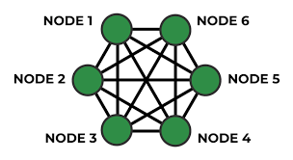

*Torus Network*: Similar to a mesh network, but the connections wrap around to form a toroidal structure, providing more direct paths between nodes.

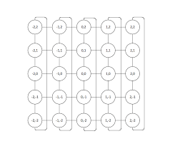

*Hypercube Network*: Nodes are arranged in a hypercube structure, and each node is directly connected to a subset of neighboring nodes based on the hypercube topology.

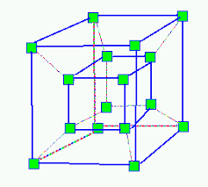

Direct networks are efficient for small to medium-scale parallel computing systems where the number of nodes is manageable, and low-latency communication is critical.

In contrast to direct networks, indirect networks utilize switching elements to connect nodes, allowing for more complex communication patterns and scalability. These networks are discussed in the next subsection.

**4.8.1 Networks to Interconnect Processors to Memory or Computers to Computers**

types of interconnection networks commonly used in computer systems:

* **Crossbar Switch**:

This is a versatile interconnection system where any processor can connect to any memory module simultaneously

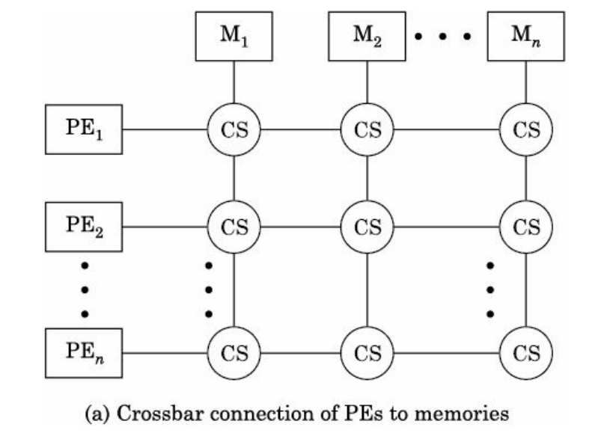







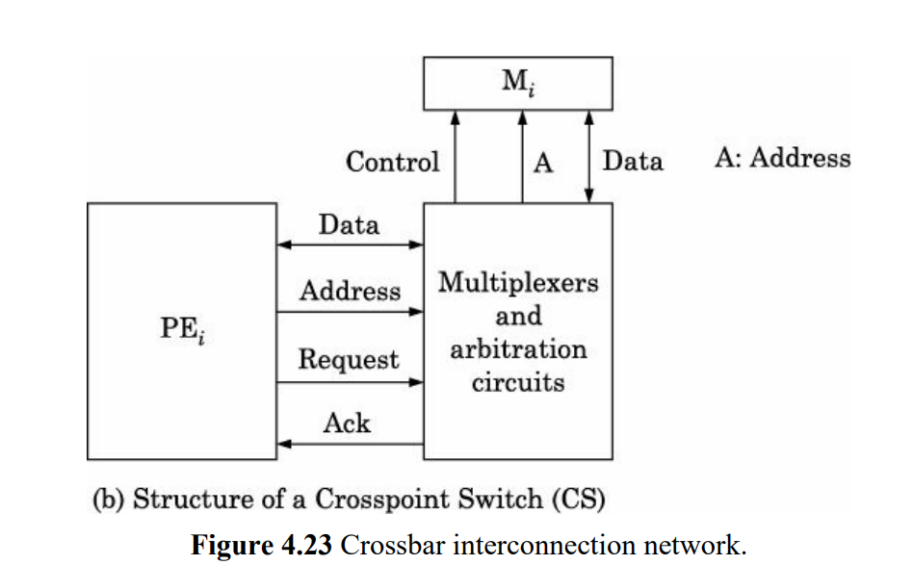

* **multistage inter-connection network or a generalized cube network :**

This network architecture is more commonly used and is structured in multiple stages.



A basic component of these networks is a two-input, two-output interchange switch as shown in Fig. 4.24. A simple interchange switch has a control input C. If C = 0, the inputs are connected straight to the corresponding outputs and if C = 1, they are cross-connected (see Fig. 4.24).

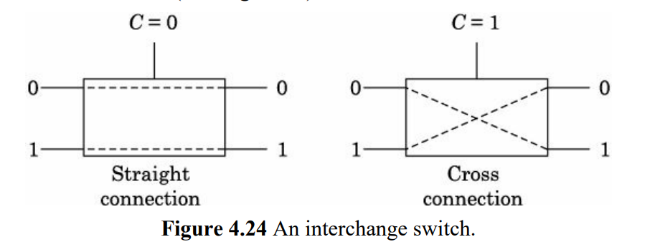

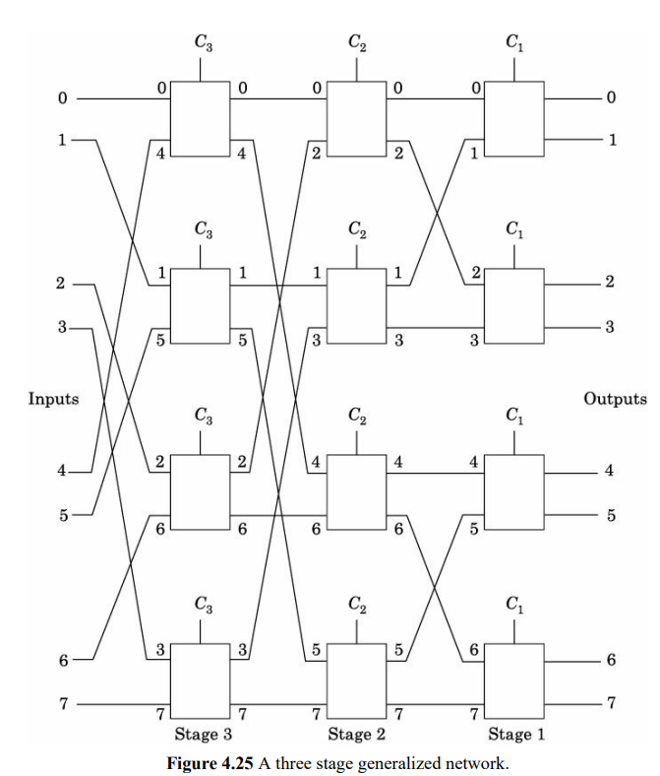

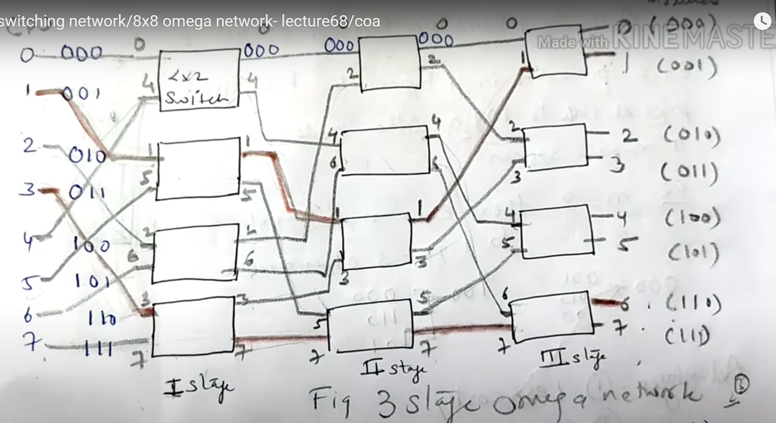



A crossbar is called nonblocking as any Pi can be connected to any Mj and at the same time another arbitrary Pr may be connected to Mq. This is not possible in the multistage network we considered. This multistage network is called a blocking network.

* **shuffle transformation**

Another popular multistage network uses what is known as a shuffle transformation.

Given a binary string (an an–1 … a2 a1 )

Shuffle (an an–1 … a2 a1 ) = an–1 an–2 … a2 a1 an

For 3 bit numbers, we get shuffle (001) = 010 and shuffle (101) = 011

In other words, shuffle transformations of a binary string is the same as left circular shifting it by 1 bit.

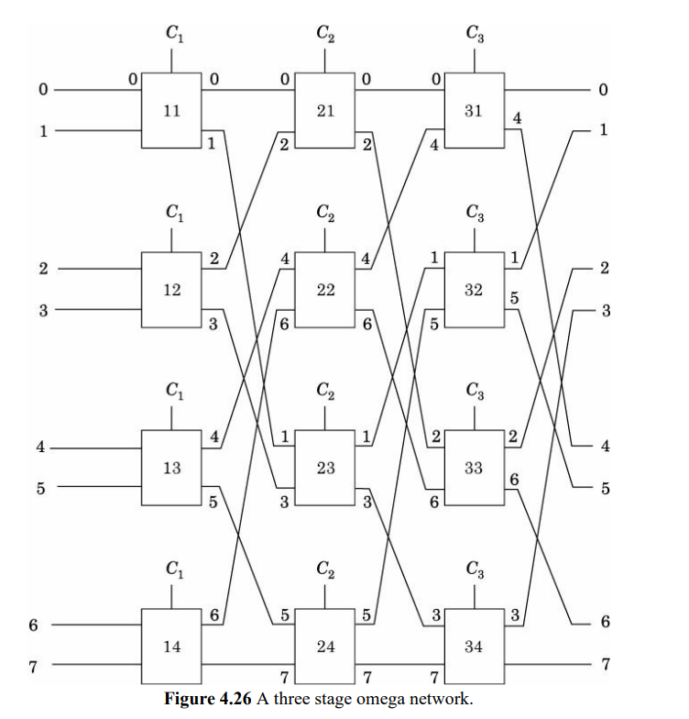

* **butterfly network**

commonly used in many commercial computers. It consists of a (4 × 4) switch using 4 butterfly switch boxes, as depicted in Figure

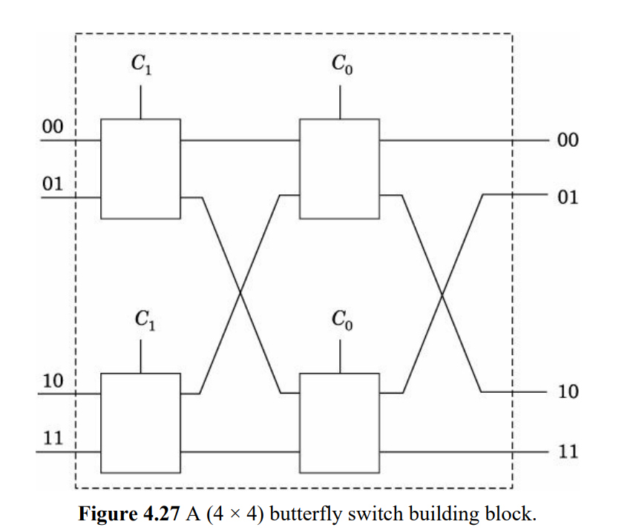

like other multistage networks, a butterfly network also does not allow arbitrary connections of N inputs to N outputs without conflicts.

To overcome this limitation, it has been shown that placing two butterfly networks back to back, such that data flows forward through one and in reverse through the other,

enables conflict-free routing from any input port to any output port.

This configuration is referred to as a Benes network

Despite its theoretical advantages, Benes networks are not widely used in practice.

**4.8.2 Direct Interconnection of Computers**

* Interconnection networks like crossbar and multistage networks can serve dual purposes, connecting processing elements (PEs) to memories or linking computing elements (CEs) in parallel computers.
* However, there are specific interconnection networks designed solely for connecting CEs in parallel computing environments.
* Early parallel computers often optimized algorithms for specific CE interconnections, which led to programs being less portable between different machines.
* Instead, the focus is on using flexible interconnection methods that offer advantages such as regularity, fault tolerance, and high bandwidth.
* Despite not being tied to a particular structure, these interconnection networks are widely used due to their overall benefits.
* One example of such a network is the ring interconnection structure.

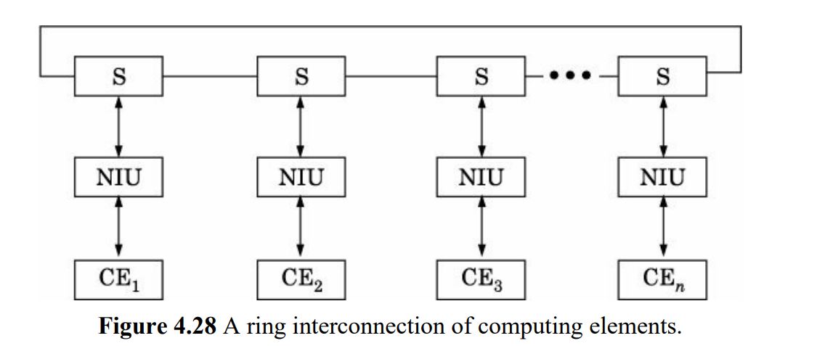

* In a ring network, each CE is linked to bidirectional switches via Network Interface Units (NIUs).
* This setup allows data to flow bidirectionally through the switches. For instance, CE2 can transmit data to CE3 while CE1 simultaneously receives data from CE4.
* Interconnection networks are characterized by four key parameters:
  + **Total network bandwidt**h: This refers to the overall bandwidth the network can support, measured in bytes per second. For a ring with n CEs and individual link bandwidth B, the total bandwidth is nB when all CEs transmit data simultaneously.
  + **Bisection bandwidth**: This parameter determines the bandwidth across a cut that divides the network into two parts. For a ring with n CEs, the bisection bandwidth is 2B, independent of n.
  + **Number of switch ports**: This indicates the number of ports each network switch has. In the case of a ring network, it is 3.   
    In a ring interconnection network, each node (or computing element, CE) is typically connected to two neighboring nodes. Additionally, there is a third port known as the "loopback" port, which allows the node to communicate with itself.
  + **Total number of links**: This parameter specifies the total number of links between switches and between switches and CEs. For a ring network, it is 2n.
* The first two parameters give an indication of the performance of the inter-connection network as they tell how fast data can be transferred between CEs. The last two parameters are proportional to the cost of switches and links which make up the interconnection system

**There are a large variety of interconnection networks that have been proposed. We will consider two of them which are quite popular.**

**2D GRID**

* Observe that CEs are all in a plane and nearest neighbours are interconnected. This network is easy to construct.

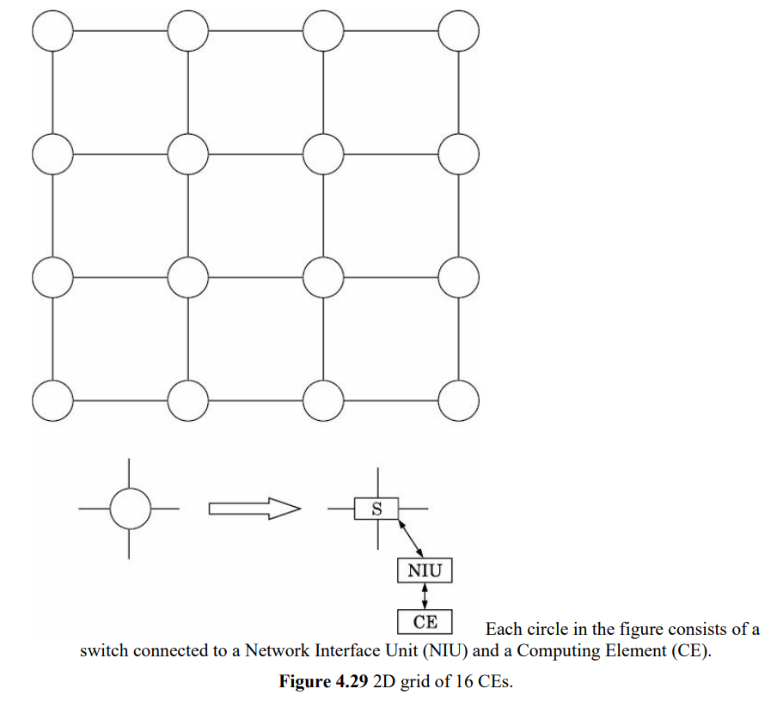

* Let's break down the characteristics of a 2D grid interconnection network with √n columns and √n rows, based on the given information: Number of ports per switch: 5 (4 to nearest neighbors, 1 to the network interface unit)

1. Links in Rows:
   * Each row has **( √n - 1 )** links connecting switches horizontally.
2. Links in Columns:
   * Each column has **( √n - 1 )** links connecting switches vertically.
3. Bandwidth of Each Connection (B):
   * This is not explicitly given but assumed to be a constant bandwidth ( B ).
   * Total Bandwidth: **2(√n - 1)B + √nB**
4. Bisection Bandwidth:
   * The bisection bandwidth is still ( **B** ), as it represents the bandwidth across the cut that divides the network into two equal halves.
5. Total Links:
   * From the given information, the total number of links can be calculated as **( 2(√n - 1) + n ).**

So, summarizing:

- Links in Rows: ( √n - 1 )

- Links in Columns: ( √n - 1 )

- Total Bandwidth: ( 2(√n - 1)B + √nB )

- Bisection Bandwidth: ( B )

- Total Links: ( 2(√n - 1) + n )

* A variation of 2D grid is a 2D toroid in which the switches at the edges of the grid are also connected by links.
* Observe that it is a more symmetric network. The disadvantage is that the network is non-planar.

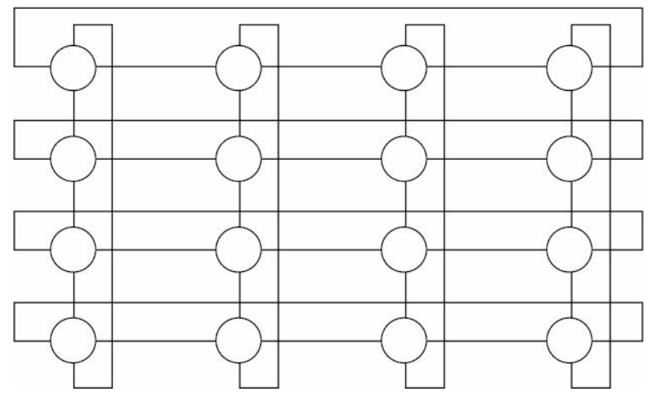

* Total Bandwidth: **2nB**
* Bisection Bandwidth: **2√nB**
* Number of Links: **3n**
* The advantage of a toroid over a regular 2D grid is its higher total bandwidth and bisection bandwidth, making it more efficient in terms of data transfer.

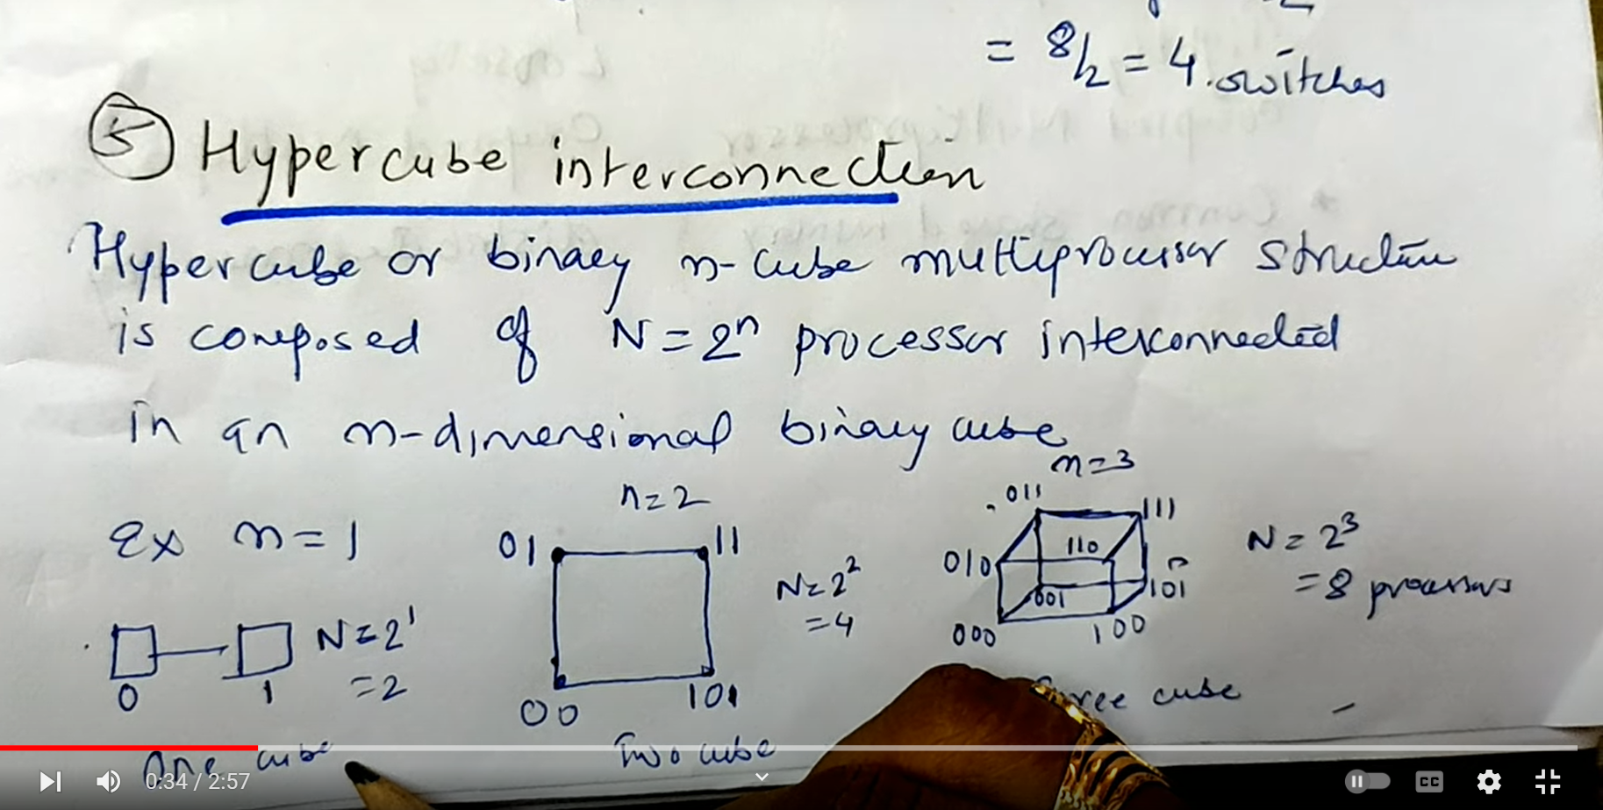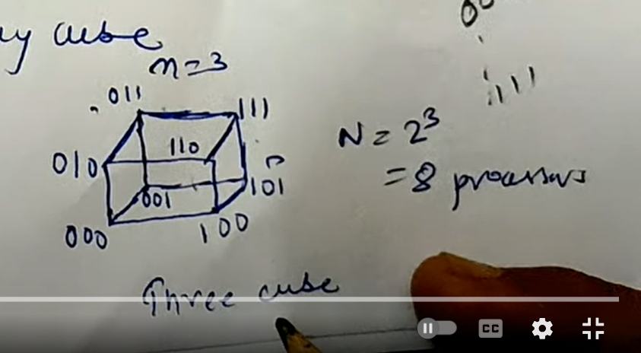





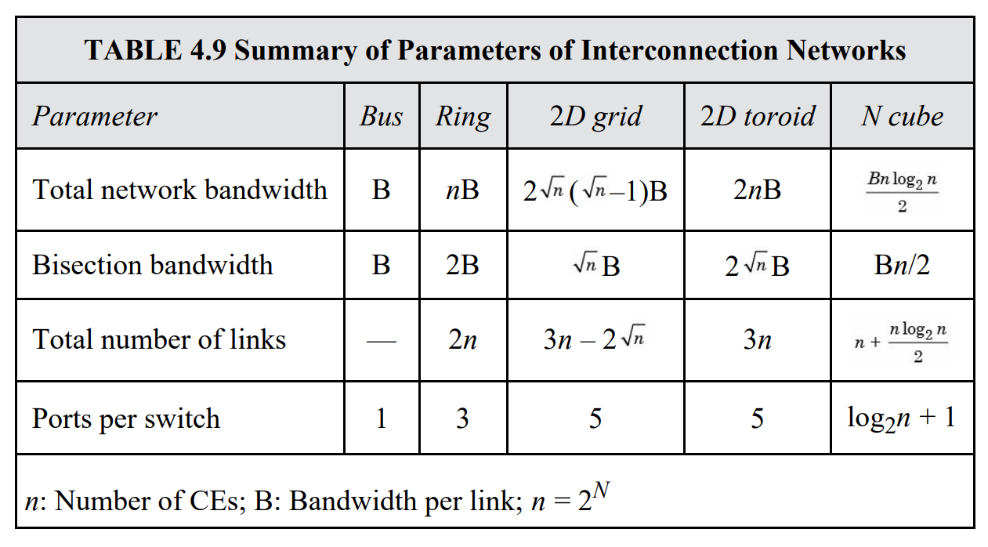

**4.8.3 Routing Techniques for Directly Connected Multicomputer Systems**

The evolution from simple switches to sophisticated routers in modern multicomputer systems has significantly improved communication efficiency. Routers, enabled by advances in integrated circuits, manage message transmission between nodes and allow simultaneous computation and communication.

1. Router Functionality:

- Routers examine incoming messages to determine if they are destined for the connected node or need to be forwarded.

- Long messages are broken into smaller packets.

- Routers use packet switching, where packets take available routes to reach destinations.

2. Buffering and Routing Methods:

- Routers need buffer storage to handle packets in transit.

- Wormhole routing subdivides packets into "flits" (flow control digits), with the first flit containing header info and subsequent flits carrying data. Flits follow the same route as the header flit, similar to a train with compartments.

- Wormhole routing is fast and requires smaller buffer space compared to packet switching but requires protocols to prevent deadlocks.

3. Advantages of Wormhole Routing:

- Faster routing compared to traditional packet switching.

- Reduced buffer space requirements.

- Asynchronous pipelining of flits ensures efficient data flow.

4. Challenges and Solutions:

- Deadlock prevention algorithms are crucial for ensuring uninterrupted packet transmission in wormhole routing.

- Many systems now employ wormhole routing in multistage interconnection networks due to its efficiency and reduced resource requirements.

**4.11 COMPUTER CLUSTER**

A computer cluster is an interconnected set of high-performance PCs or servers used to achieve high-speed parallel computing.

1. Architecture:

- The architecture of a computer cluster, as shown in Fig. , involves interconnected nodes or PCs, each with its own processor and network interface.

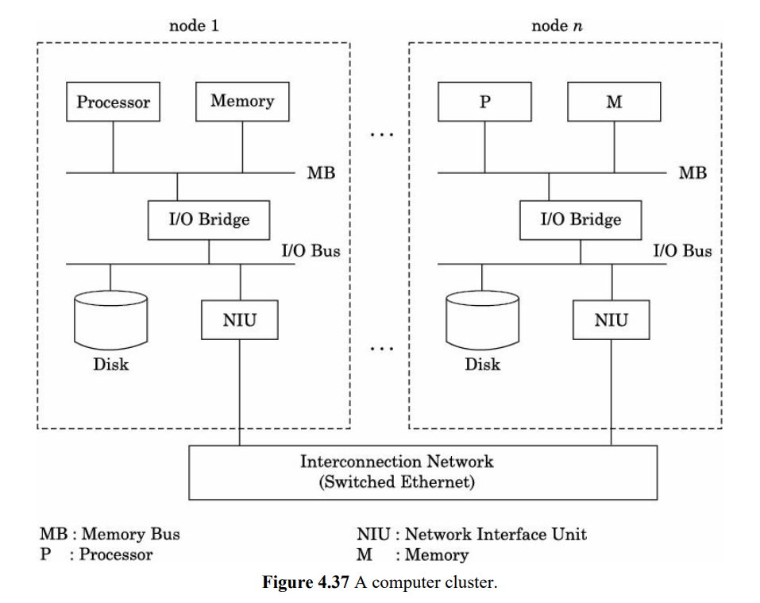

- Unlike traditional message passing multicomputers where the NIU is connected to the memory bus, in a computer cluster, the NIU is connected to the I/O bus.

1. Message Passing and Performance:

- Computer clusters can be programmed using the message passing method, similar to traditional parallel computers.

- However, the time taken for message passing between nodes in a computer cluster is significantly higher (thousands of clock cycles) compared to dedicated message passing parallel computers.

- The use of the I/O bus for message transmission, although slower, is standardized and compatible across different manufacturer's computers.

1. Programming and Applications:

- Computer clusters are effective for Single Program Multiple Data (SPMD) style programming.

1. Performance Potential:

- Despite the limitations in message passing speed compared to dedicated parallel computers, computer clusters can still achieve significant performance.

**4.11.1 Computer Cluster Using System Area Networks**

Here's a summary of the key points about System Area Networks (SANs) in the context of computer clusters using SANs:

1. Purpose of SANs:

- SANs are designed to bridge the gap between Local Area Networks (LANs) and high-performance multicomputer interconnection networks.

- The goal is to connect a small number of standard "off the shelf" computer boards that are physically close together (a few meters) with high-speed, highly reliable communication and reduced communication overhead.

2. Communication Characteristics:

- SANs are characterized by low communication delays, aiming for microseconds of overhead for sending and receiving messages. This is in contrast to LANs, which typically have millisecond-level communication delays.

- The communication protocol used in SANs is optimized for high-speed, low-latency communication within a localized cluster of computers.

3. Benefits:

- high-speed communication, reliability, and reduced overhead compared to traditional LANs.

- They are suitable for building medium-cost high-performance parallel computers.

4. Usage in Computer Clusters:

- SANs are increasingly being used in computer clusters.

- These SAN-based computer clusters leverage the benefits of SANs to achieve improved performance and efficiency in parallel computing tasks.

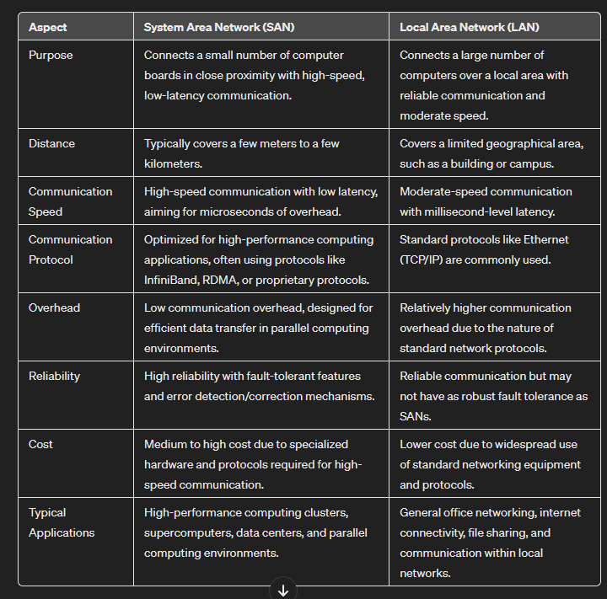

* + 1. **Computer Cluster Applications**

1. Load Distribution:

* Clusters are often used to distribute computational tasks efficiently.
* By analyzing the requirements various jobs in a batch, a scheduler can allocate these tasks to different nodes in the cluster.

1. High Availability Systems:

* Clusters enhance system reliability by providing redundancy.
* If a node in the cluster fails, tasks running on that node can be automatically transferred to a healthy node, ensuring continuous operation.
* Moreover, running programs on multiple nodes simultaneously and comparing their results can improve fault tolerance.

1. Web Farms:

* Websites with high traffic, such as those for major services like Indian Railways, benefit from clustering.
* Multiple copies of the website can be hosted across cluster nodes, allowing load balancing and fault tolerance.
* During peak times, additional nodes can be added dynamically to handle increased traffic, showcasing the elasticity of cluster setups.
* This type of parallel processing, known as request-level parallel computing, is particularly useful when handling diverse and independent tasks from multiple users simultaneously.

1. Rendering Graphics:

* Rendering complex 3D graphics demands significant computational power.
* Clusters can divide rendering tasks into smaller segments and distribute them across multiple nodes.
* This parallel processing approach accelerates rendering times.
  1. **GRID COMPUTING**

1. The Globus project, led by Ian Foster and colleagues in the late 1990s, was crucial in defining and advancing grid computing. A computer grid is an infrastructure that allows multiple organizations to collaboratively use high-end computers together.
2. As Internet speed and communication networks improved, the distance between clients and servers became less crucial. This allowed organizations to collaborate globally and share not just high-performance computers but also scientific instruments, databases, and specialized software.
3. The Globus project developed standard tools for grid computing systems, aiming to coordinate decentralized resources using open protocols. This enhances the quality of service for users accessing grid resources.
4. Grid computing is crucial for "Big Science" projects, enabling global collaboration among scientists. It facilitates efficient sharing of computational resources, data, and scientific instruments, enhancing scientific and engineering research.